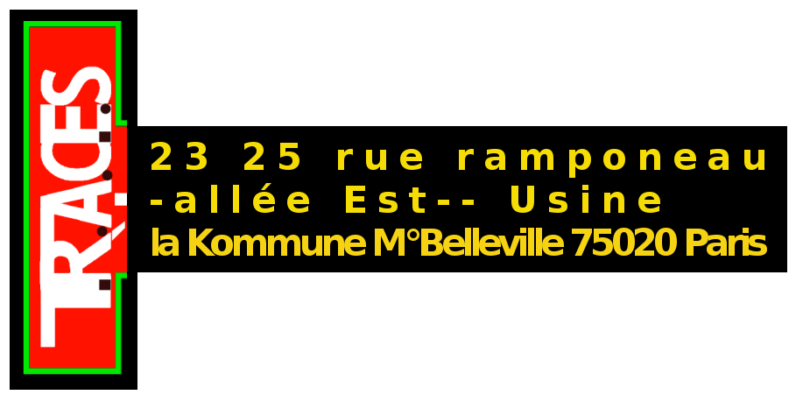

(33) o9 52 75 31 51
06 03 79 77 09
tracesp@free.fr
http://tracesp.free.fr

MODALITIES for CANDIDATURES
and File of Candidature

Candidates should send a dossier consisting of:

1/ A Curriculum Vitae
2/ A dossier (about 10 pages) about the artistic advance: presentation of artistic career and artistic realisations, eventually with digital support (CD).

The dossier should specify the following points:

a/ The artist's professional engagement in artistic life,

Justify a n° d’adhésion at “maison des artistes” or l’AGESSA (or inscription in course for young artists) and a n° de SIRET.

b/ The presentation of the demarche and the artistic projet in the framework of the candidature for a residence and the projet T.R.A.C.E.S. à la Forge.

2/ The dossier of the artists shall be studied by a commission nominated by the “Conseil d'administration”. An interview with the members of the Commission is planned for the candidates retained.

Important: postal address:

T.R.A.C.E.S.
24 rue Ramponeau
75020 Paris (France)



File of Candidature

Name:
First name:
pseudonyme:
Address:

Telephone: mobile phone:
Email:
Web site:

Numéro Maison des Artistes ou AGESSA:
Numéro de Siret:

Desired residence time (3 to 6 months)
Presentation of your project in a few lines:

